**Hahn.ApplicationProcess.July2021.Web**

This project need the following Packages to run

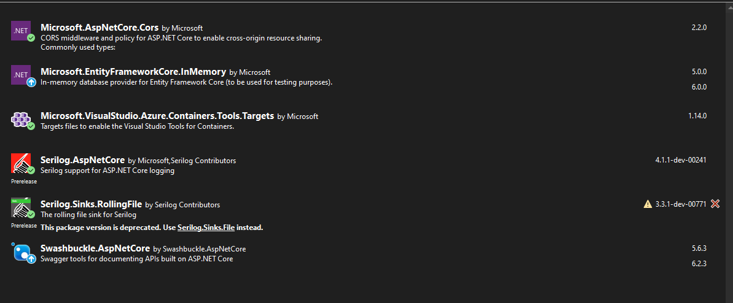

**Hahn.ApplicationProcess.July2021.Domain**

This project need the following Packages to run

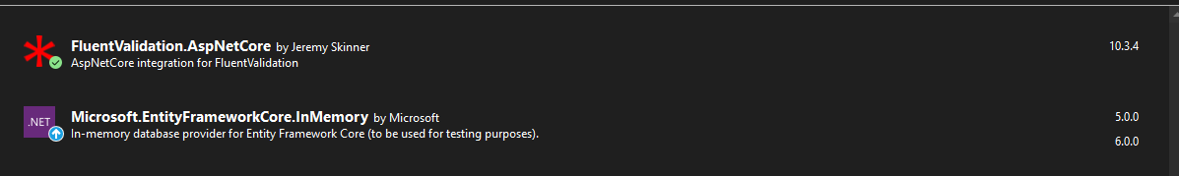

**Hahn.ApplicationProcess.July2021.Data**

This project need the following Packages to run



Chose Huhn.applicationProcess.july2021.Web for the debug